Glendale Strong Family Network Thursday
April 13th, 2023
1:00 2:30PM meeting via Zoom

Attendees: Genesis Verduzco (Equality Health), Betsy Musson (Pendergast), Noemi (Molina Healthcare), Leslee Miele (GESD), Denis Parcells (GESD), Leticia Abarca (Glendale), Davida Solter (GESD), Aimee Sitzler, Peggy Peixoto,

Arizona ACE Consortium – Sandi Cimino
REP School Program-
- Goal is to increase trauma informed practice in the school
  - Start talking with adults about safety and relationships
  - Every school has trauma-informed ambassador
  - Every training has an MSW present
  - No cost to an organization, provide stipends to school

Community Organizations Training-
- Goal is to show how to implement and support resilience within their organization. With a heavy focus on adults as well as the youth they're serving
- One-time training – for organization directly or indirectly serving youth

Youth Training-
- 3 separate sessions, approx. one hour each
- Focused on understanding stress and creating their own resilience
- Every training has MSW
- Includes journal with activities
- Talk with adults about what is being taught to the teens

Programs restricted to Maricopa County
If you or an organization you know would like more information please contact Sandy at Sandy@azaces.org

Back to School Partner / Food Event
Formed 2 AD HOC groups to help: one to focus on food and one on a location
- Location – Currently still seeking a location
  - Have contacted several businesses and churches with larger spaces
  - Could potentially have it at System of Care Center if needed
  - Contacted Desert Diamond Arena –
    - Will rent space to us for $5K to $7K and may be able to get corporate sponsor
    - This will be a scaled up event
    - Available in July on the 22nd
- Having a special board meeting to see if we should seek corporate sponsors

Feedback Results Regarding Event:
- We like the immediate community level event - more manageable than big scale up to keep event the size it was
- Sponsorships can still happen
- We are a partner driven – organization
- Denis also has connection with the county to get immunizations at the event
  - 4 buildings will be under remodel that are not able to be utilized
  - We can collaborate with Tomachoff Farms for parking if needed
  - Most of the families there were from GESD
- Market as a “Community Food and Backpack” event instead of back to school

- Date for System of Care Center: July 22nd from 8am to 11am

- Can use St. Mary’s Food Bank form for sign-in sheets like last time

- For food box distribution – can have volunteers put together the boxes beforehand this time instead of having families pick from the food St. Mary’s brought.

- Elvie is working on contact with Purchase Local –

Early Childhood Nutrition Team – Online Training offered -
“Healing with Food: Models for Positive and Joyful Eating and Feeding”
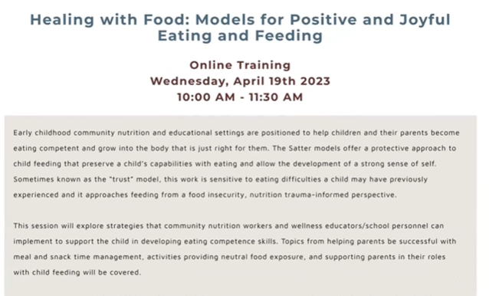
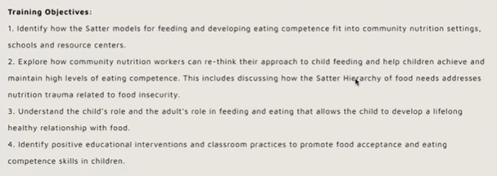

Aimee will be sending the recording out to the partners

Purchase Local – Food Resource
- 12 million dollars for AZ being distributed through schools and community partners for community events
- Can fill out online form to apply
- We will fill out for our community event
- Here are the links:
  - https://www.purchaselocalaz.org/about.html
  - https://www.purchaselocalaz.org/community-partners.html

Next Meeting May 11th 1:00pm

